**LAB ASSIGNMENT - 3**

**Shell Scripts**

1. To find Largest of Three Numbers.

**Solution:**

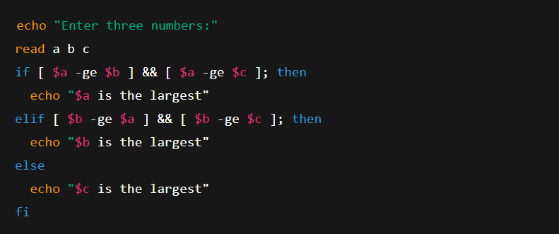

2. To find a year is leap year or not.

**Solution:**

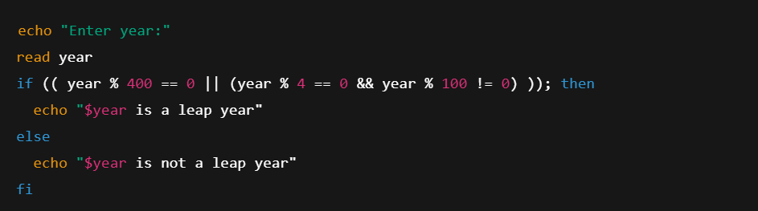

3. To input angles of a triangle and find out whether it is valid triangle or not

**Solution:**

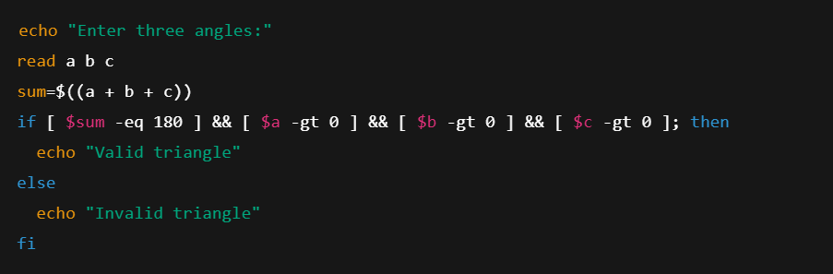

4. To check whether a character is alphabet, digit or special character.

**Solution:**

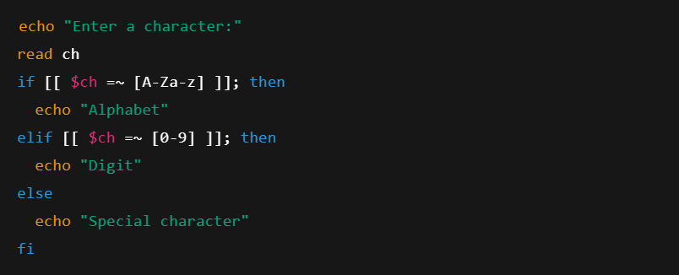

5. To calculate profit or loss.

**Solution:**

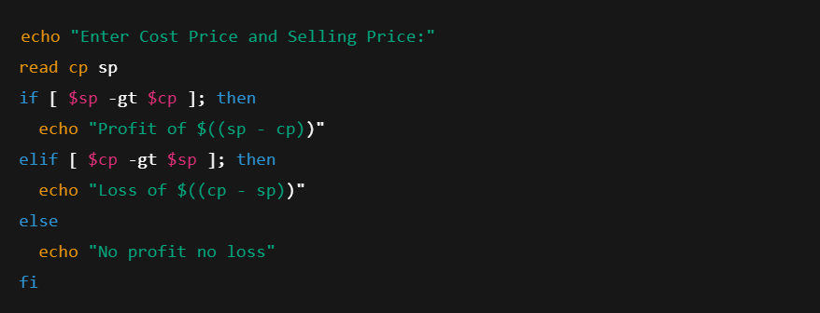

6. To print all even and odd number from 1 to 10

**Solution:**

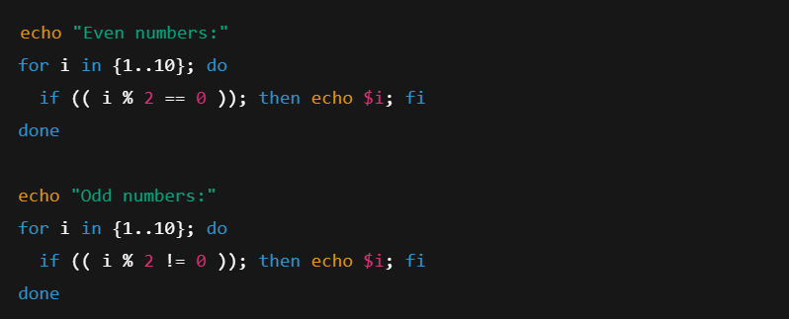

7. To print table of a given number

**Solution:**

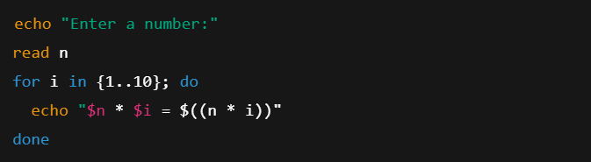

8. To find factorial of a given integer

**Solution:**

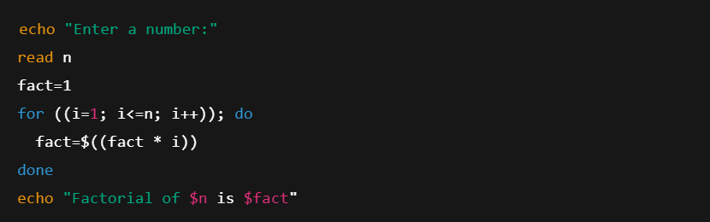

9. To print sum of all even numbers from 1 to 10.

**Solution:**

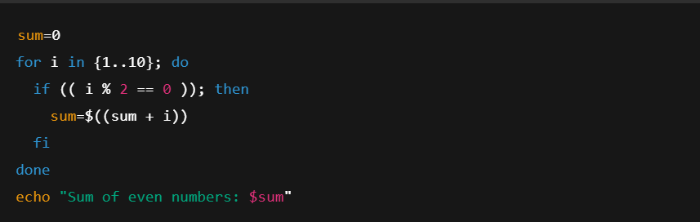

10. To print sum of digit of any number.

**Solution:**

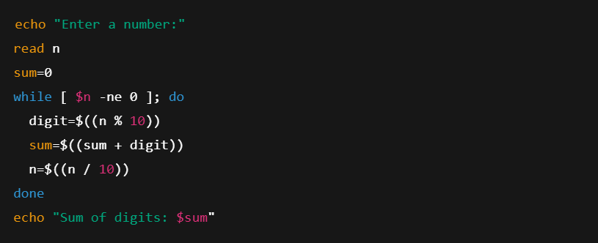

11. To make a basic calculator which performs addition, subtraction, Multiplication,

Division

**Solution:**

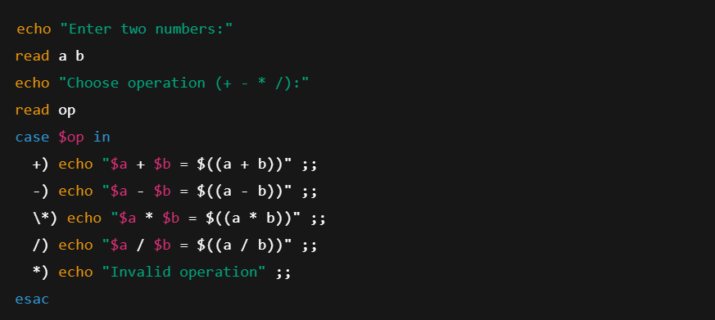

12. To print days of a week.

**Solution:**

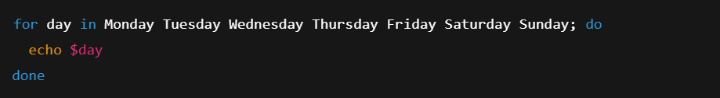

13. To print starting 4 months having 31 days.

**Solution:**

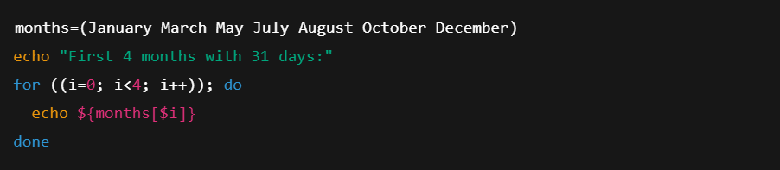

14. Using functions,

a. To find given number is Amstrong number or not

**Solution:**

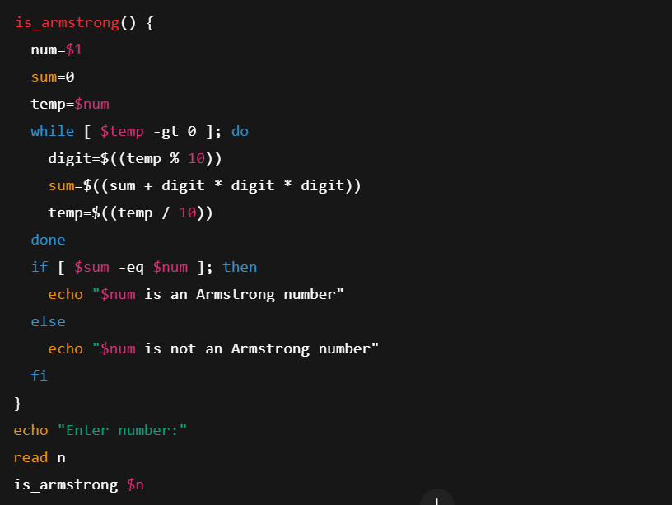

b. To find whether a number is palindrome or not

**Solution:**

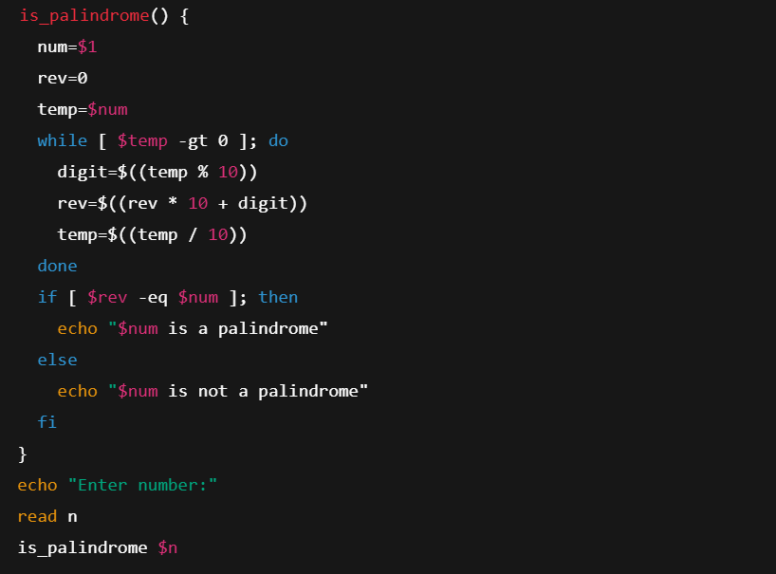

c. To print Fibonacci series upto n terms

**Solution:**

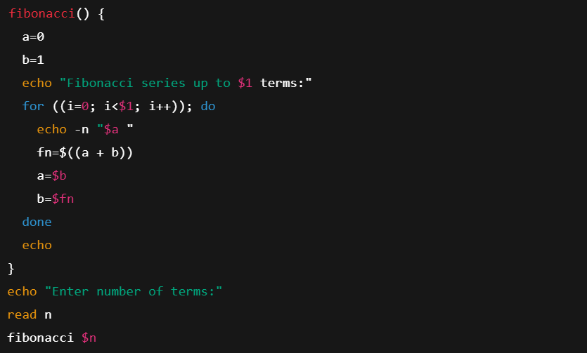

d. To find given number is prime or composite

**Solution:**

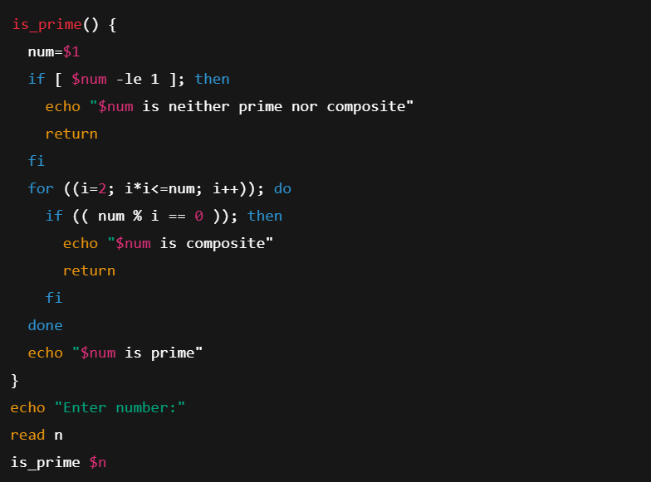

e. To convert a given decimal number to binary equivalent

**Solution:**

